OFFICIAL COORDINATION REQUEST FOR
NON-ROUTINE OPERATIONS AND MAINTENANCE

COORDINATION TITLE- 12LWG 006 new barge moorage facility
COORDINATION DATE- 5 June 2012
PROJECT- Lower Granite Dam
RESPONSE DATE- 14 June 2012 – June FPOM meeting

Description of the problem –

The Corps proposes to construct a new deep foundation piling supported moorage facility and mooring dolphin that will accommodate up to eight (8) of the larger 8000 Series fish transport barges. The purpose and need of this new fish transport barge moorage facility and dolphin is to add to the existing moorage facility located along the shoreline of the Lower Granite earthen fill section to accommodate O&M and repairs of the existing barge fleet, replacement of existing barge equipment and/or additional barges, and improve simultaneous access to multiple barges for transferring high weight supply.

The Lower Granite Dam serves as the O&M hub for the existing Corps Juvenile Fish Transportation barges, where maintenance, repairs, and over wintering of barges occurs. The fish transport barges require essential maintenance to be routinely performed that include ensuring all engines and circulation pumps are maintained and in good operating condition; ensuring fish release openings and related equipment operate properly; removing inside edges off joints, cleaning holding tanks, removing and installing net pens in barge holds for transport of steelhead kelts or other isolated populations; installing oxygen monitoring probes and testing monitoring system operation for water temperature, dissolved oxygen, and de-gassing of total dissolved gases (TDG) supersaturation.

Currently an existing moorage facility sits immediately north of the Lower Granite Dam Navigation Lock and approximately 300 feet (ft) southwest from the new proposed location. Due to its configuration, the existing facility limits the number of barges that can be serviced at one time due to their moorage tied 3-4 barges abreast, thus restricting the reach of necessary equipment required to maintain, repair, or supply the barges, such as cranes. Most equipment must be carried by human hand over multiple barge railings and gunwales. The existing moorage facility was designed for six (6) barges, but routinely moored all eight (8) barges upon the completion of constructing the newest replacement barges of the 8000 Series. The newest replacement barges have become larger in size and capability, but at least two (2) barges had to be moored and stored on the upriver navigation lock wall when not in-service. However, due to lack of adequate alternate moorage facilities at other Dam locations, and frequent routine and non-routine maintenance required, currently eight (8) fish barges are frequently tied to the existing Lower Granite moorage structure. The current configuration requires the affected fish transport barges be directly adjacent to the mooring cells for crane access and moving any heavy equipment and machinery on or off the barge. This often requires additional resources (e.g., tugs and lockages upriver/downriver) to shuffle and relocate barges for adequate access to the affected barge, throughout the year. This takes a significant amount of time and labor to move barges around.

Although, a couple of the smaller original barges were to be retired, the transport program needs for direct loading at multiple dams and research has retained most of these older and smaller barges of the 2000 and 4000 Series. These limitations in accessible mooring have affected timely repairs, which in turn can negatively affect fish transport operations.

The action area is the “cul-de-sac” located immediately on the downriver side of Lower Granite earthen fill section between the navigation lock and the north shoreline. The action area is a footprint of about 5.5 acres in size, of which about 1.5 acres is directly related to the new moorage wharf coverage (0.1 ac) and intermittent shading of docking and smolt migration off-season storing of 8 barges (1.4 ac).

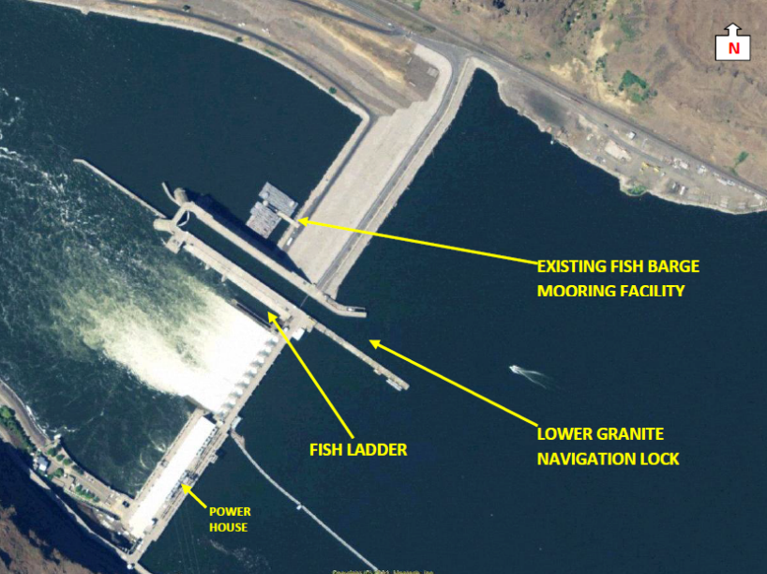
Figure 1. Aerial view of the Lower Granite Dam, navigation lock, fish ladder, in relation to the existing fish barge mooring facility located adjacent to the north side of the navigation lock, and immediately downstream of the toe of the earthen portion of the non-overflow dam.

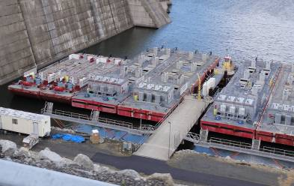
Figure 2. Existing fish transport barge mooring facility has limited access to barges which restricts necessary services (heavy equipment operations) to those that are immediately adjacent to the existing structure.

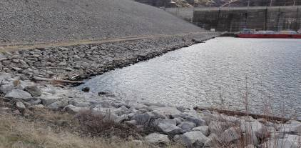
Figure 3. Existing moorage facility in background; foreground represents location of the proposed north shore and toe pile support fish transport barge facility. Access road is located along top of the dam toe (left, road runs parallel with shoreline)

The new moorage facility is basically a wharf approximately 400 ft in length, and positioned parallel and along the toe of the earthen fill section creating an “L” shaped configuration with an approximately 200 ft in length perpendicular arm constructed along the north shore.

The new wharf will be built over the toe of the earthen fill on two rows of 4.5-ft diameter drilled shafts (one row of 31 pilings located on shore and a second row of 27 pilings located in water); precast concrete cap beams, and pre-stressed precast concrete slabs. The toe slope is protected by riprap, which will require some removal during construction phase. Other work such as excavation, clearing, grubbing, and trenching for utilities will occur simultaneously with pile (shaft) installation. The on-shore and in-water pile supports, concrete caps and slabs are connected together by a final 6-inch cast-in-place concrete closure pour. The wharf will extend out into the river approximately 40-ft from shore. The overall footprint of the wharf is approximately 0.39 acres with about 0.1 acre over-water. During the juvenile fish passage season of April through August when the reservoirs are operated at Minimum Operation Pool (MOP) water surface elevation of 633’, the wharf will cover approximately 6-8’ of water depth with about 20’surface water to shore under the wharf. At Full Pool water surface elevation of 638’, the wharf will cover approximately 11-13’ of water depth with about 30’ surface water to shore under the wharf.

Type of outage required – None, all winter in-water work window 15 Dec 2012 through 1 March 2013.

Impact on facility operation – None anticipated, positive effect on timeliness of needed repairs; and pre-season and in-season O&M on 8 smolt transport barges to maximize their availability, reliability, and rotation for direct loading and AFEP research objective treatments from any of the three Snake River smolt collection and loading facilities.

Dates of impacts/repairs - Winter in-water work window 15 Dec 2012 through 1 March 2013.

Length of time for repairs – 75 days

Expected impacts on fish passage – None routine, positive effect to system survival for reducing number of occurrences and number of smolts within a season that are dumped from the raceways through bypass that the BiOp directs to transport due to unavailability of series 2000, 4000, and 8000 barges.

Comments from agencies –

Final results -

Please email or call with questions or concerns.
Thank you,

Greg Moody
509-527-7124

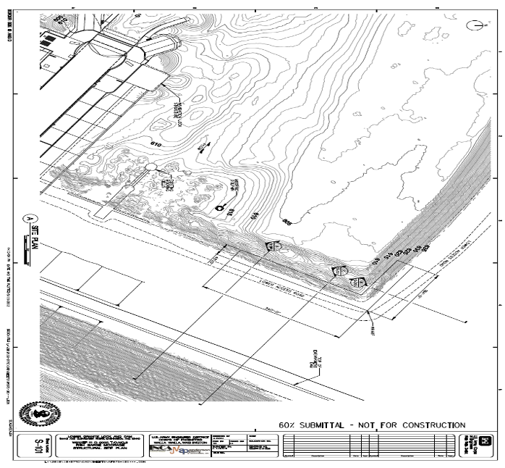

Figure A. LGR Transport Barge Moorage site plan.

Figure B. LGR Transport Barge Moorage pile structure.

Figure C. LGR Transport Barge Moorage cross-section through earthen-fill.

Figure D. LGR Transport Barge Moorage Dolphin details and section.

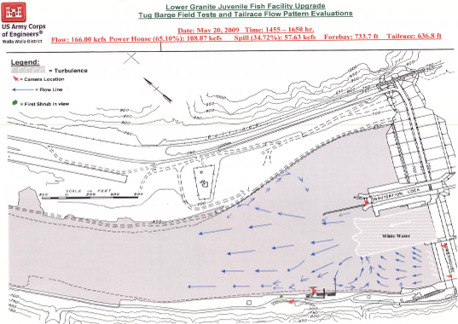

Figure E. 2009 field test tailrace flow pattern evaluation at Lower Granite. This figure represents a high flow condition spill event in May. LGR spring operations spill 20 kcfs 24 hours; TDG fish cap ~ 41 kcfs. Eddy on the north shore with an inflection point about 900 - 1,000 feet downstream of the navigation lock guide wall and an upstream extent near the downstream end of the navigation lock guide wall.

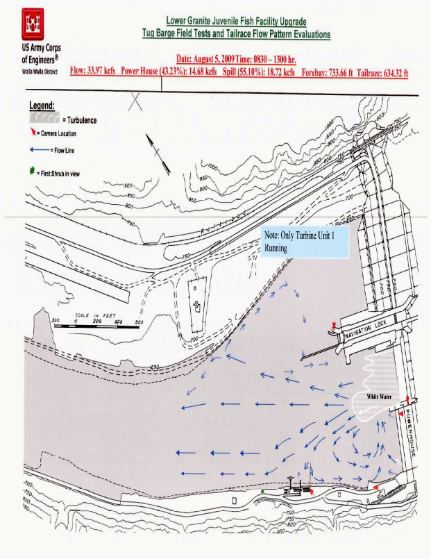

Figure F. 2009 field test tailrace flow pattern evaluation at Lower Granite Dam. This figure represents a low flow condition spill event during August. LGR summer operations spill 18 kcfs; TDG fish cap ~ 41 kcfs. The back eddy flow does not extend all the way to the toe of the dam where the proposed work will take place.

